## ****Ordering a WiFi Router via ServiceNow Service Catalog****

### ****1. Objective****

The project is focused on improving the process of ordering WiFi routers for employees. Traditional methods, such as email requests or manual forms, often lead to delays, errors, and inefficiencies. By leveraging the ServiceNow Service Catalog, we aim to:

* Provide employees with a streamlined, self-service process for ordering IT equipment.
* Enable managers to efficiently approve requests based on predefined workflows.
* Automate backend processes, such as inventory checks and email notifications, to ensure timely delivery.

This initiative is especially critical for remote employees who require reliable internet connectivity to perform their roles effectively.

### ****2. Business Goals****

#### ****Primary Objectives:****

1. **Reduce Downtime:** Ensure that employees have the equipment they need without unnecessary delays.
2. **Increase Productivity:** Allow employees to focus on their work rather than administrative tasks.
3. **Enhance User Experience:** Simplify the ServiceNow interface to make it intuitive for users of all skill levels.

#### ****Secondary Objectives:****

* Minimize errors by standardizing the request process.
* Improve transparency by providing request tracking for users and administrators.
* Support organizational growth by designing a scalable system.

### ****3. Implementation Overview****

This project uses ServiceNow as the backbone for automating the WiFi router ordering process. Key components include:

* **Service Catalog:** Acts as the interface for employees to submit requests.
* **Workflows:** Automates the approval and fulfillment processes.
* **Notifications:** Keeps all stakeholders informed at every step.

By integrating these elements, the project ensures smooth and efficient service delivery, reducing manual intervention and enhancing user satisfaction.

### ****4. Prerequisites****

Before starting, ensure the following:

1. **Access to ServiceNow Developer Instance:** Sign up on [ServiceNow Developer Portal](https://developer.servicenow.com" \t "C:\\Users\\STANIS\\AppData\\Local\\Temp\_new) to obtain a personal instance.
2. **Knowledge of ServiceNow Features:**
   * Service Catalog: For creating catalog items.
   * Workflows: For automating processes.
   * Email Notifications: For sending updates to users and approvers.
3. **Basic IT Skills:** Familiarity with IT equipment terminology and approval hierarchies.

### ****5. Implementation Steps****

#### ****Step 1: Accessing ServiceNow Developer Instance****

1. Sign up or log in to the ServiceNow Developer Portal.
2. Navigate to **Personal Developer Instances** and request a new instance.
3. Configure the instance with necessary plugins for catalog and workflow functionalities.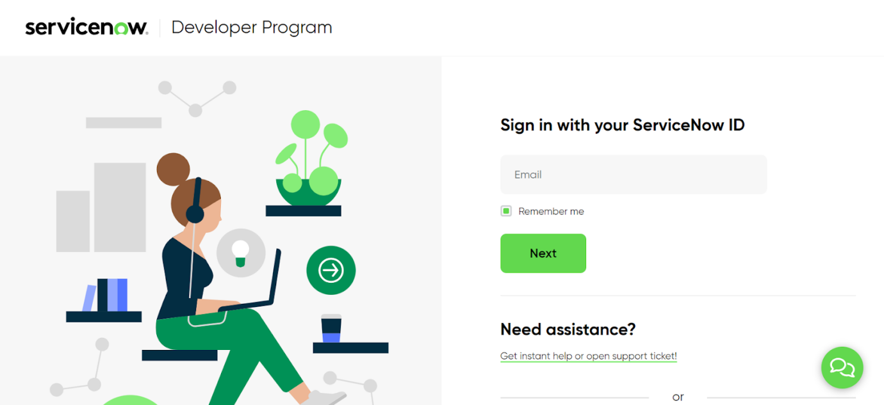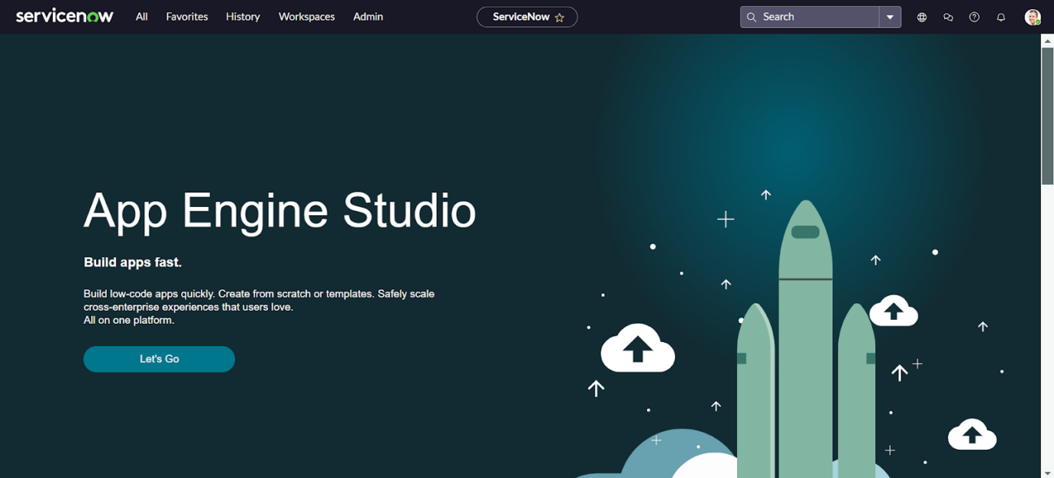

#### ****Step 2: Setting Up Categories and Items****

1. Go to **Maintain Categories** and create a new category titled "IT Equipment Requests."
2. Customize the category by adding images/icons for better user experience.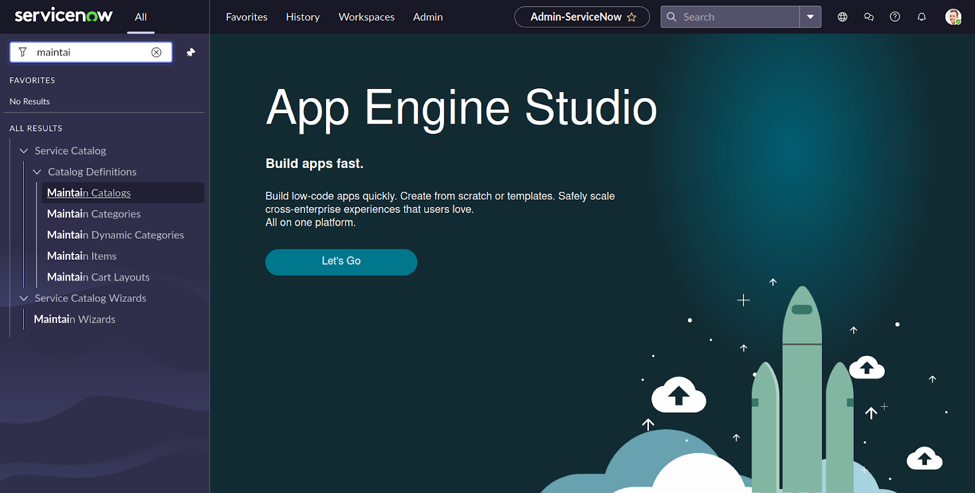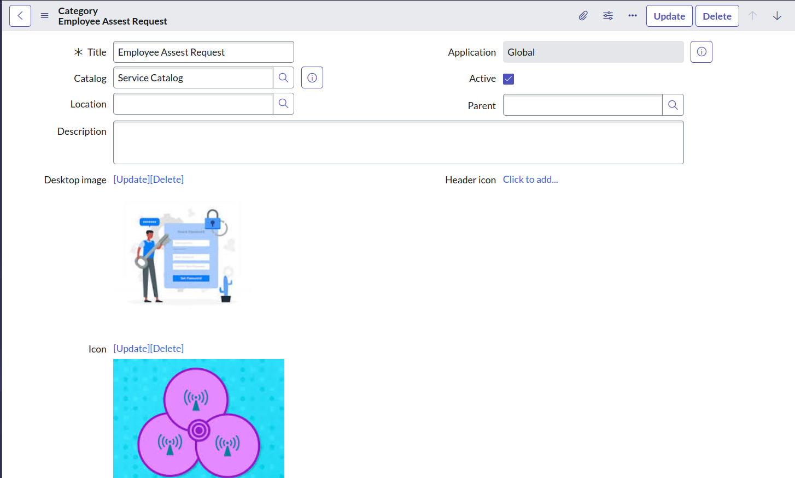
3. Save and proceed to **Maintain Items.**
4. Create a new catalog item titled "WiFi Router Request" and assign it to the "IT Equipmentrequests"category.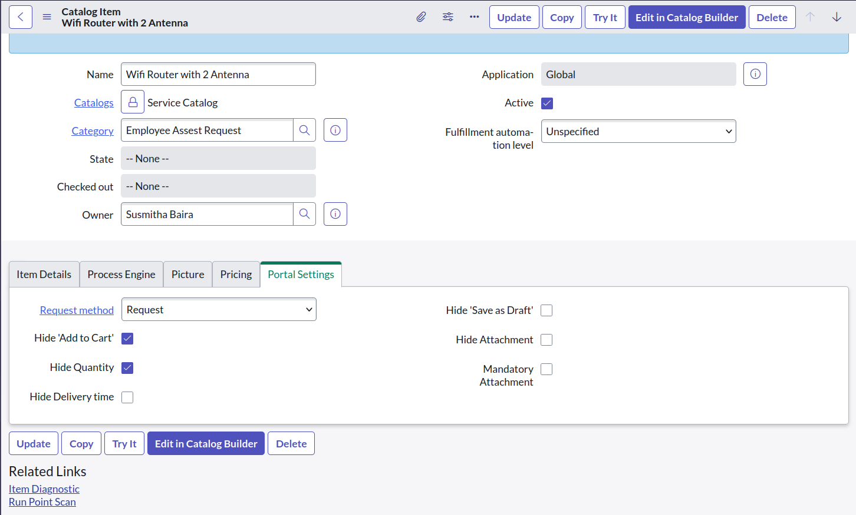

#### ****Step 3: Adding Variables****

Variables capture specific user inputs. Examples include:

* **Router Type:** Dropdown menu (e.g., Basic, Advanced, High-Speed).
* **Quantity:** Numeric input for the number of routers needed.
* **Delivery Date:** Calendar input for scheduling delivery.
* **Comments:** Text area for additional notes or requirements.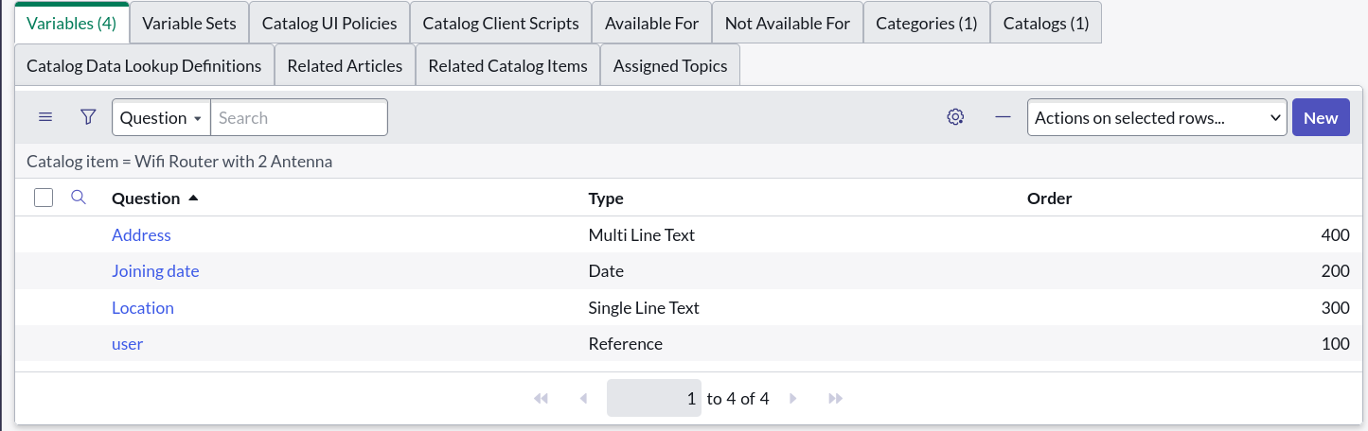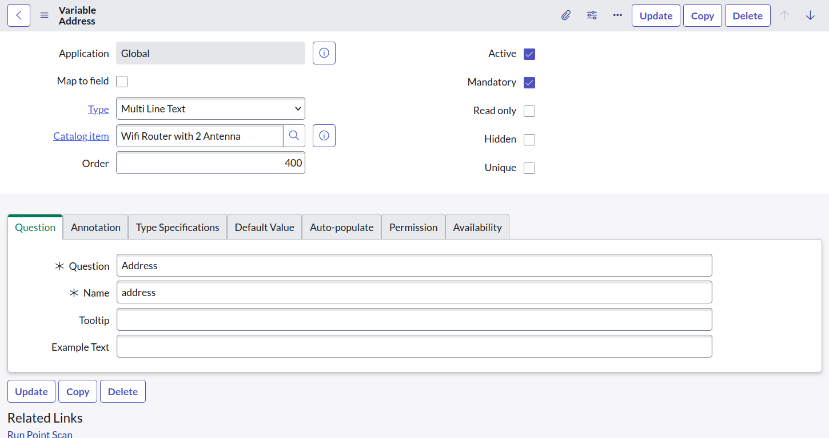

Step 4 : Open “Portals”:  
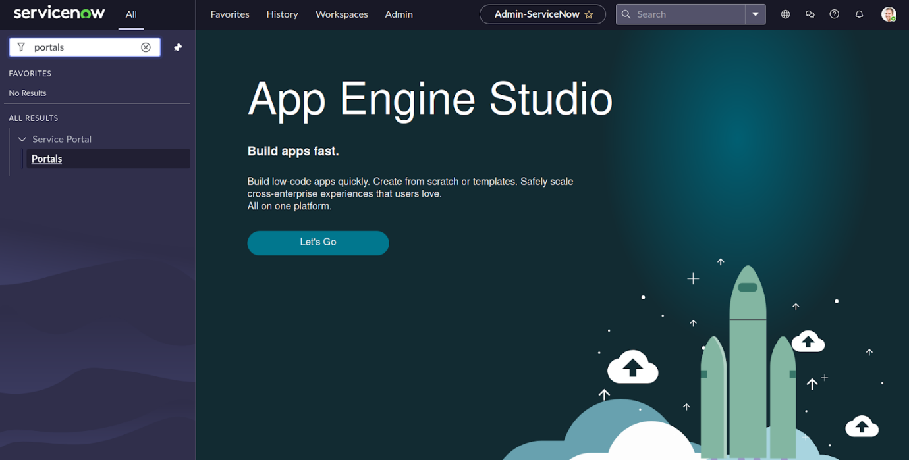

Step 5:  Select Service Portal

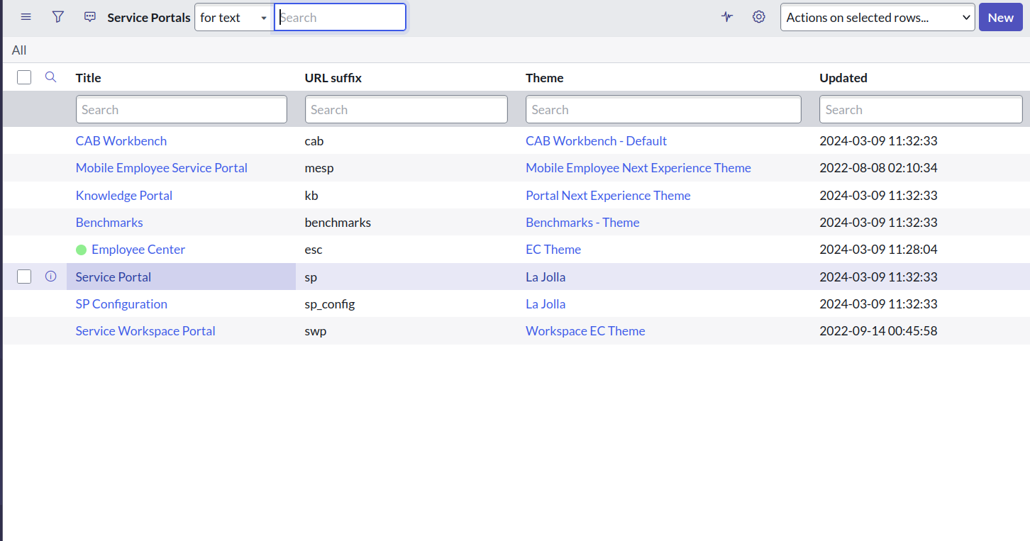

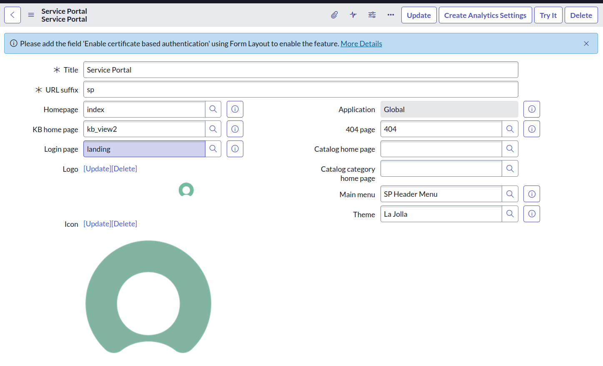

**Step 6 : Select Catalogs**

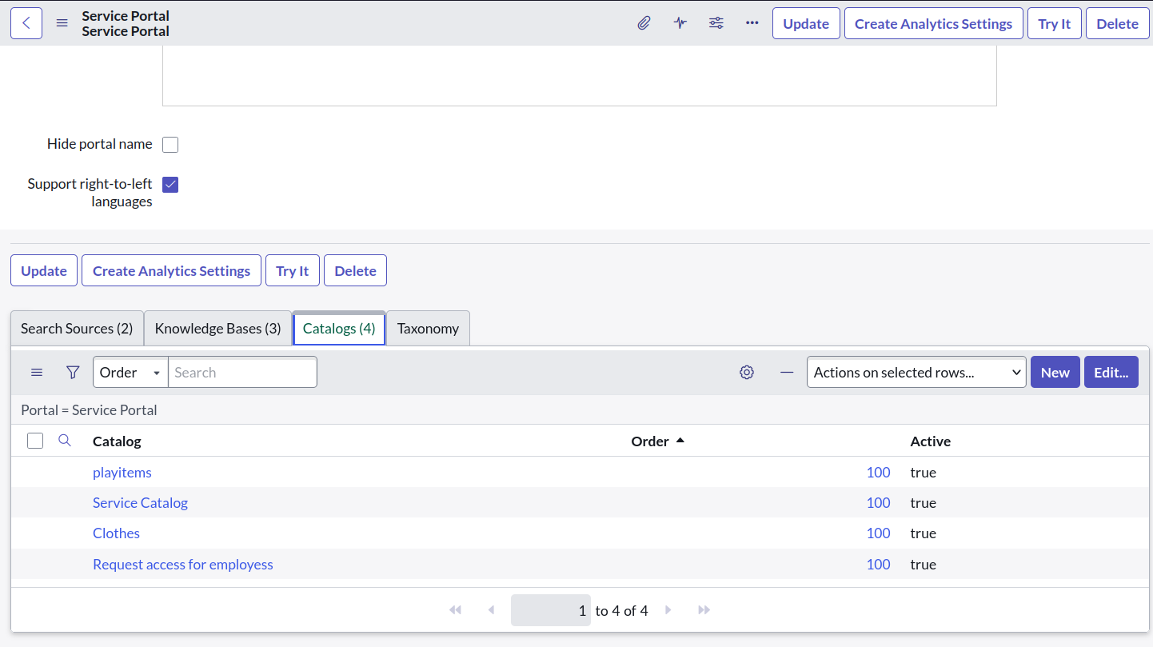

Step 7 : Select Edit

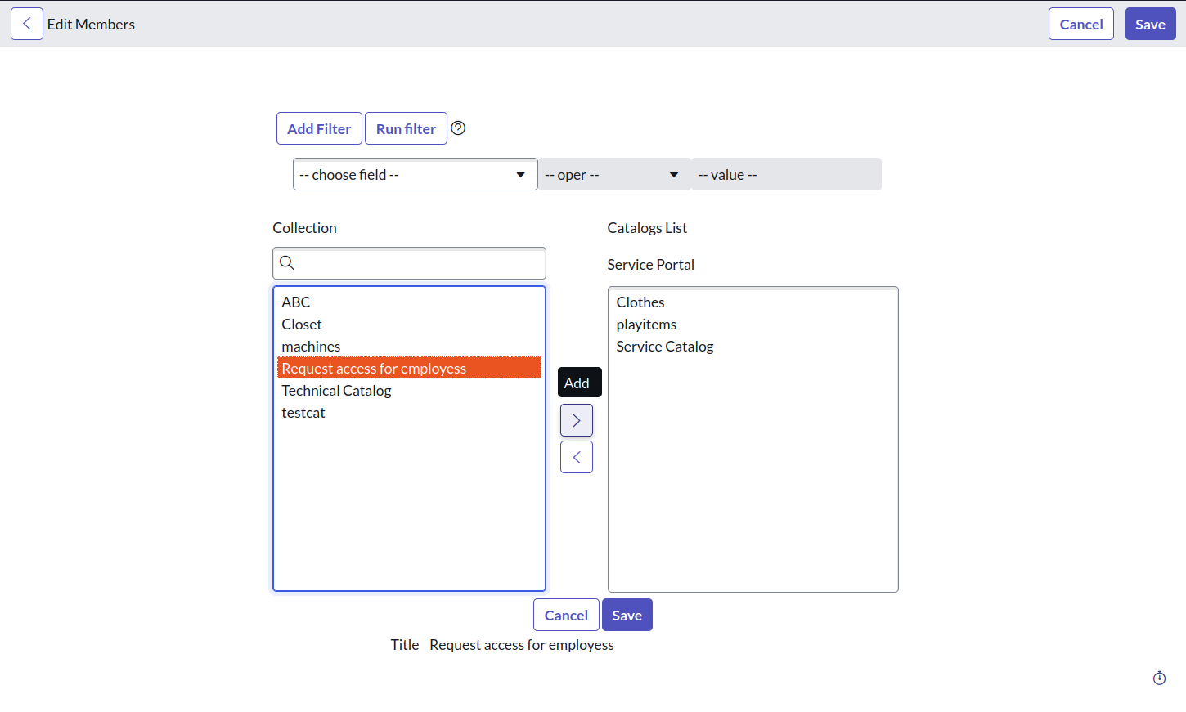

 Select the Category and Add to Service Portal and Save

**Step 8: Designing Workflows**

1. Use the **Workflow Editor** to create an approval workflow.
2. Define stages such as:
   * Request submission.
   * Managerial approval.
   * Inventory check and order processing.
3. Add automated notifications for approvals, rejections, and order completion.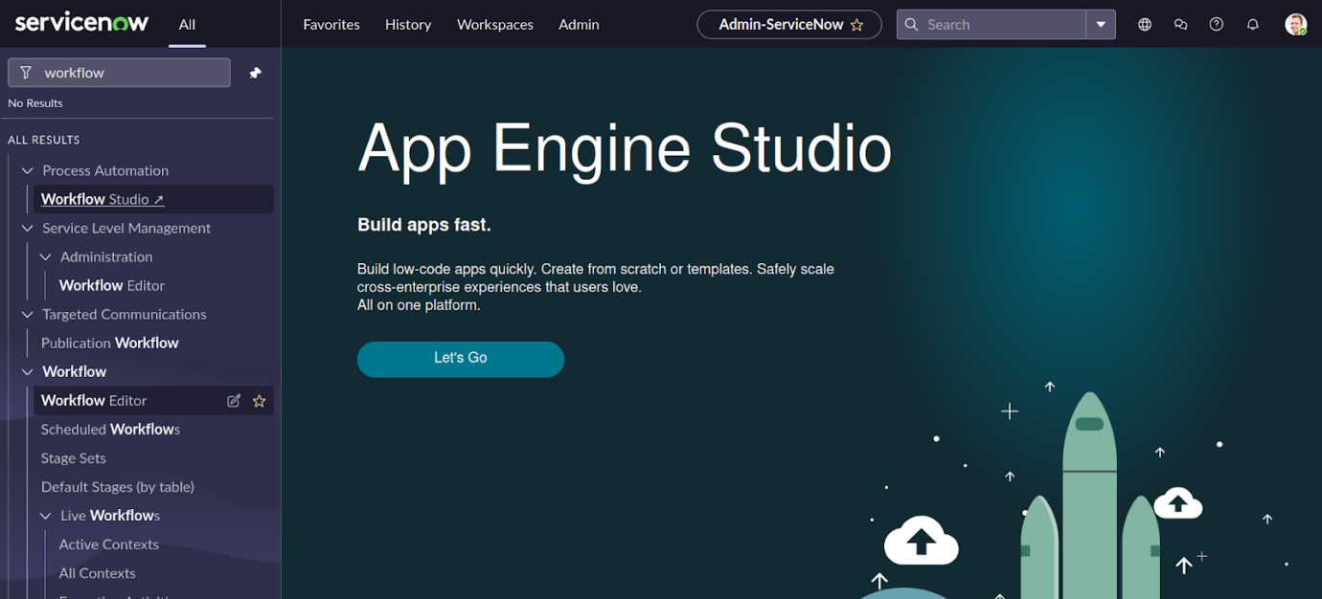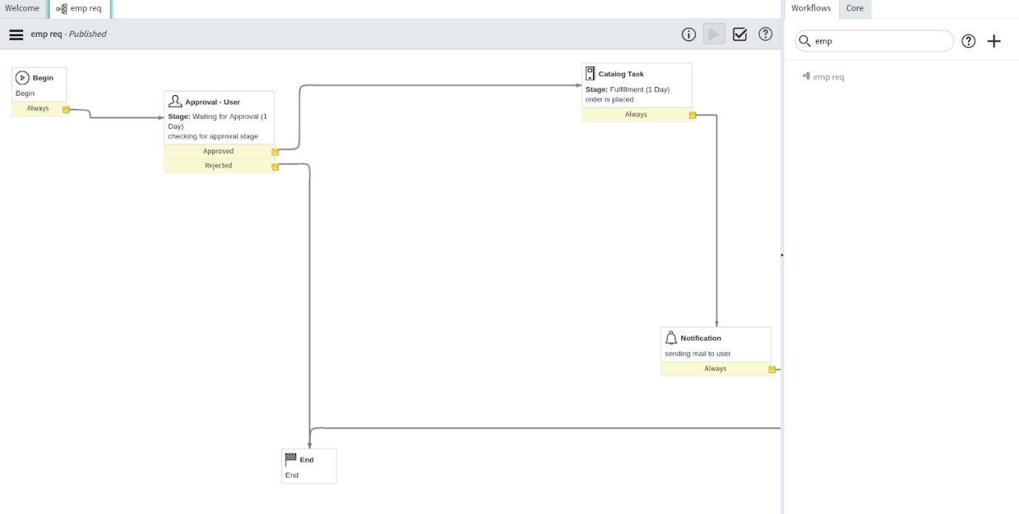

#### ****Step 9: Configuring Notifications****

1. Set up email notifications to inform users and approvers.
2. Customize templates to include order details, status updates, and estimated delivery times.

#### ****Step 10: Testing the Workflow****

1. Use the impersonation feature to test as a typical user.
2. Validate the end-to-end process, from request submission to order fulfillment.

Step 11 : Add the workflow to the item

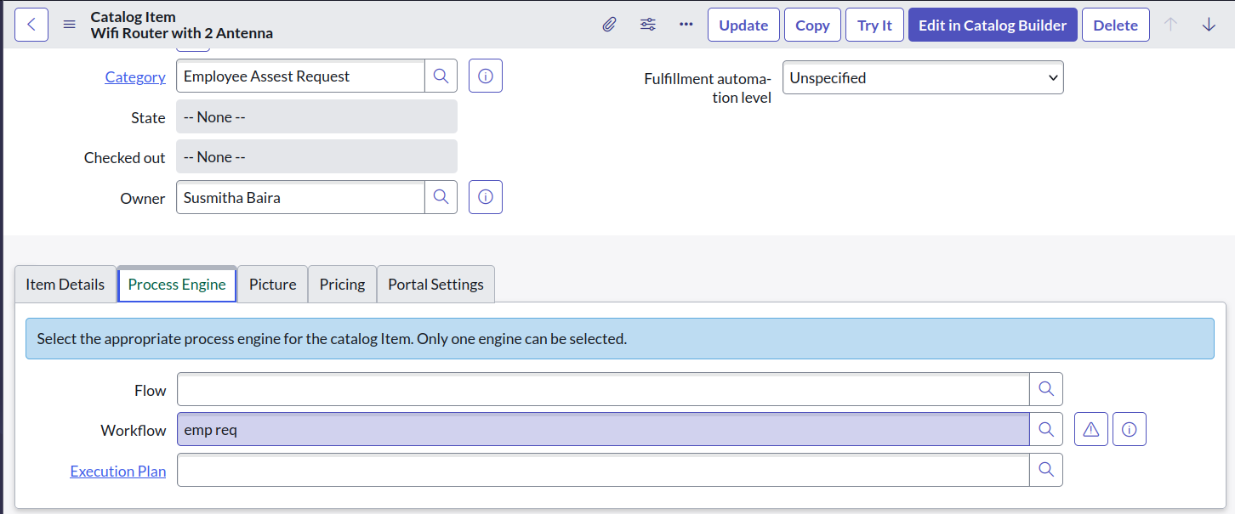

Step 12 : Open Service Portal and make a Request for item

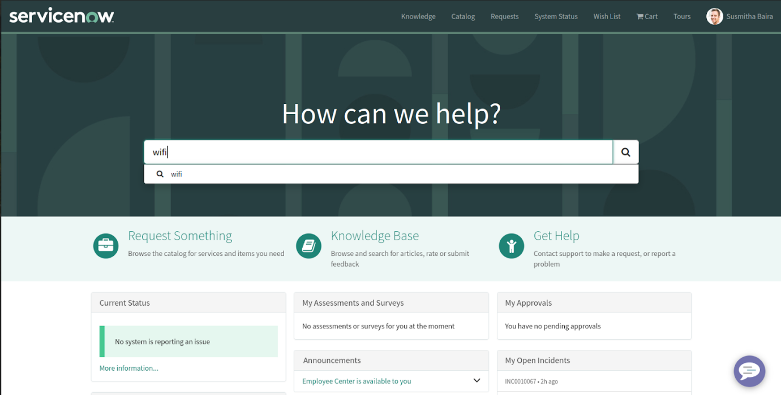

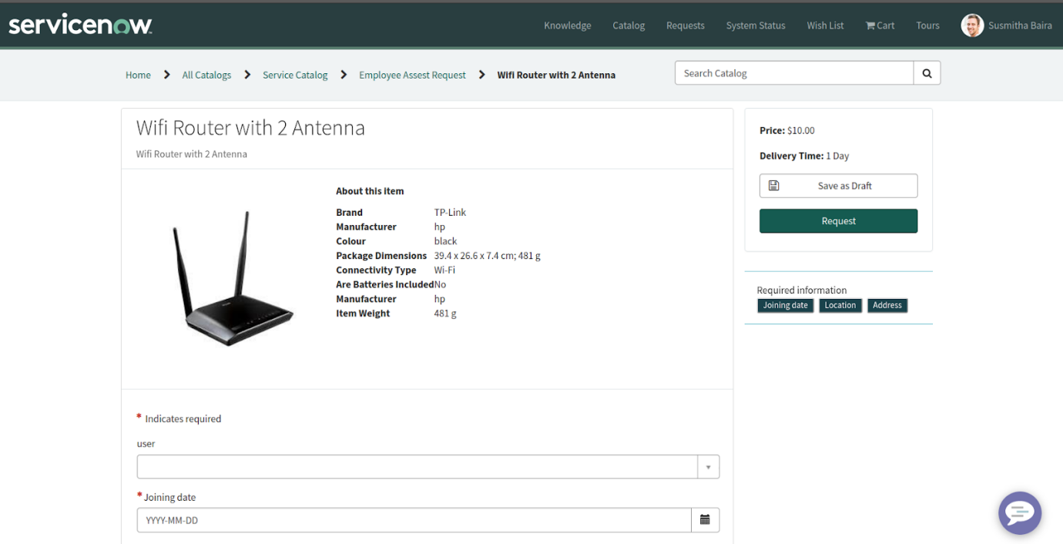

Enter additional variables (such as quantity, preferred delivery date, and comments) below the item field in a request form and then submit the request.

Step 13 : Placing Request

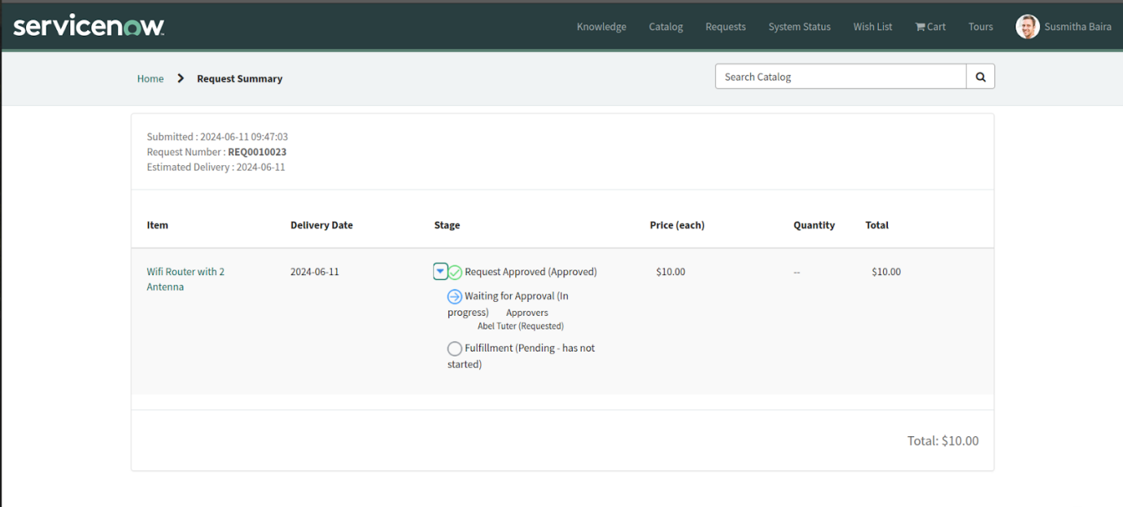

Step 14 : Open “My Requests”

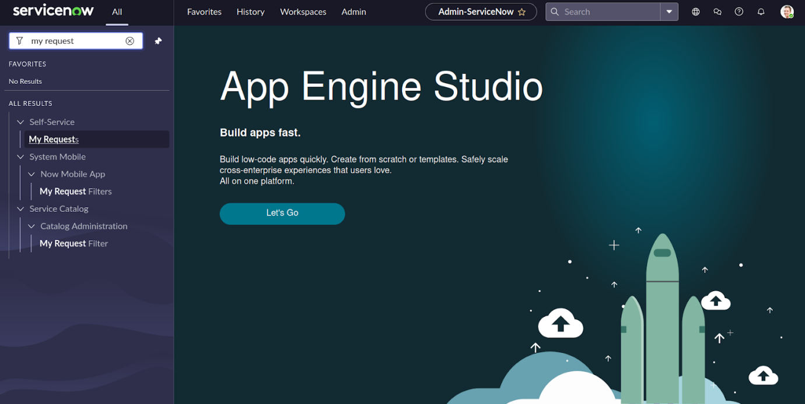

Step 15 : Open Request Record

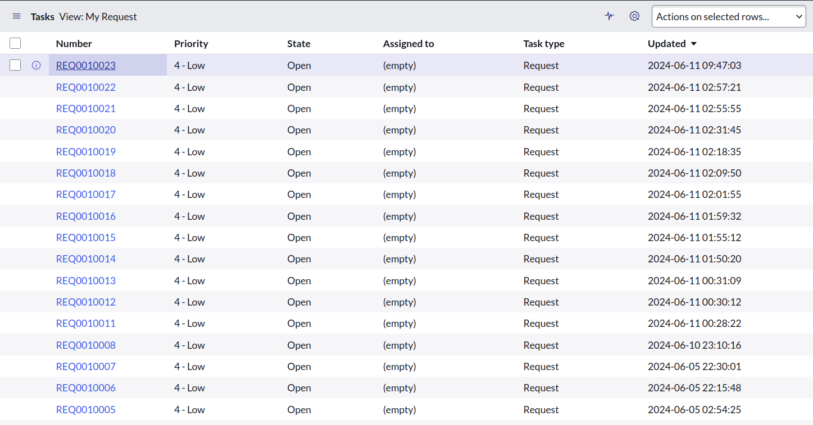

Step 16 : Open Request item

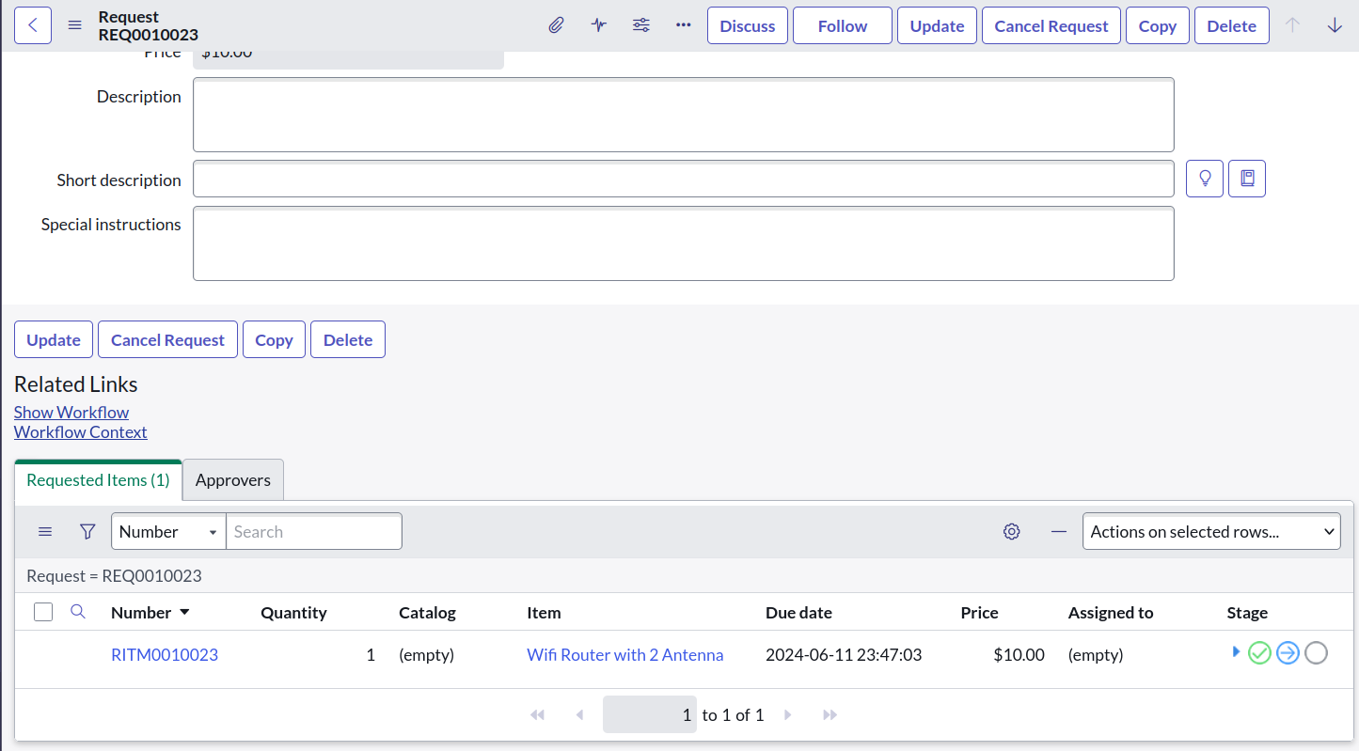

Step 17 : waiting for approval

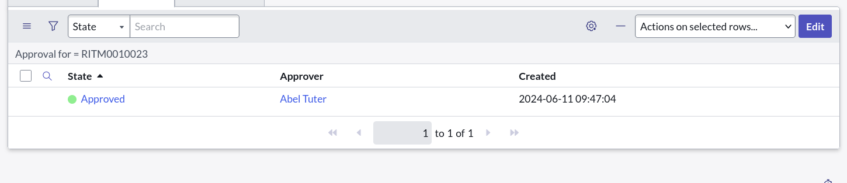

Then task is created

Step 18 : Open the Service Catalog Task

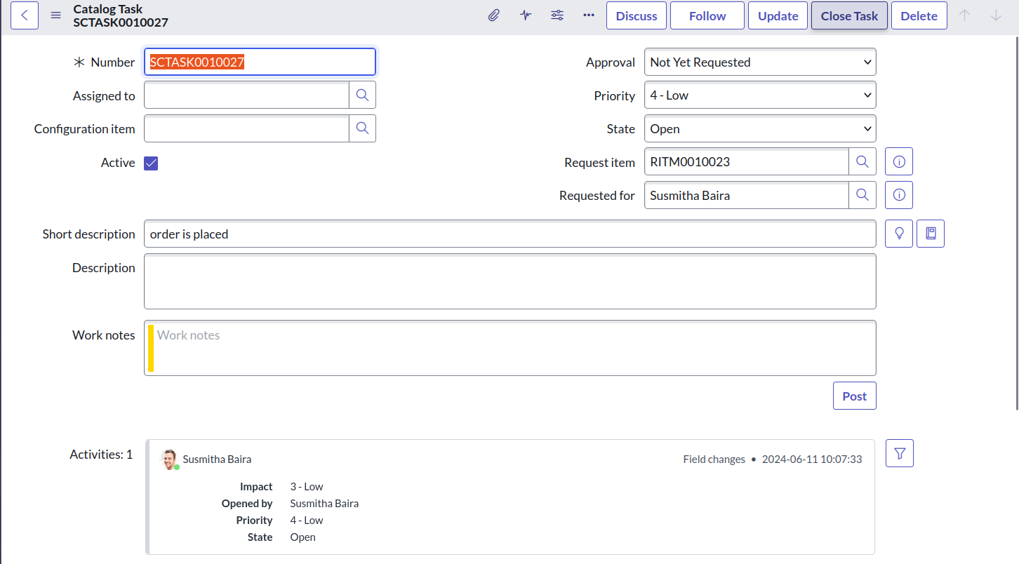

Click on Close task

### ****6. User Scenario****

#### ****Example Scenario:****

John, a remote marketing professional, experiences frequent connectivity issues due to his outdated router. Using the ServiceNow Service Catalog, John submits a request for a high-speed router. After his manager approves the request, the system automatically checks inventory and processes the order. Within days, John receives the router, resolving his connectivity issues and improving his productivity.

Include a **visual flowchart** of this process.

### ****7. Advanced Features****

To future-proof the system, consider these enhancements:

* **Dynamic Catalogs:** Display only items relevant to the user’s role.
* **Integration with Asset Management:** Automatically update inventory records post-fulfillment.
* **Conditional Approvals:** Auto-approve low-cost items while routing expensive requests for managerial review.

### ****8. Testing and Validation****

#### ****Testing Scenarios:****

1. **Positive Test Case:** Submit a valid request and validate successful processing.
2. **Negative Test Case:** Submit an invalid request (e.g., missing variables) and check error handling.
3. **Edge Case Testing:** Test high-volume requests to ensure system stability.

#### ****Validation Steps:****

* Verify that all workflows function as intended.
* Ensure notifications are sent at each critical stage.
* Test scalability for large user bases.

### ****9. Troubleshooting****

#### ****Common Issues:****

1. **Workflow Errors:**
   * Check transition logic in the Workflow Editor.
   * Ensure all conditions are properly defined.
2. **Missing Notifications:**
   * Verify email server configurations.
   * Check notification rules for proper triggers.
3. **Role-Based Access Issues:**
   * Confirm user roles and permissions in the ServiceNow admin panel.

### ****Result****

Email Notification will be sent

Step 1 : Open “Emails”

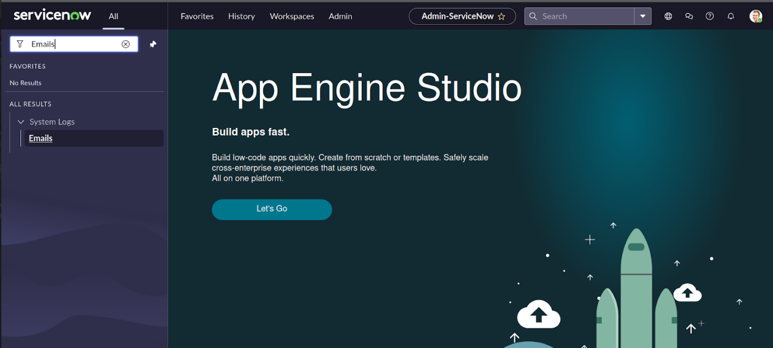

Step 2 : Check the Email

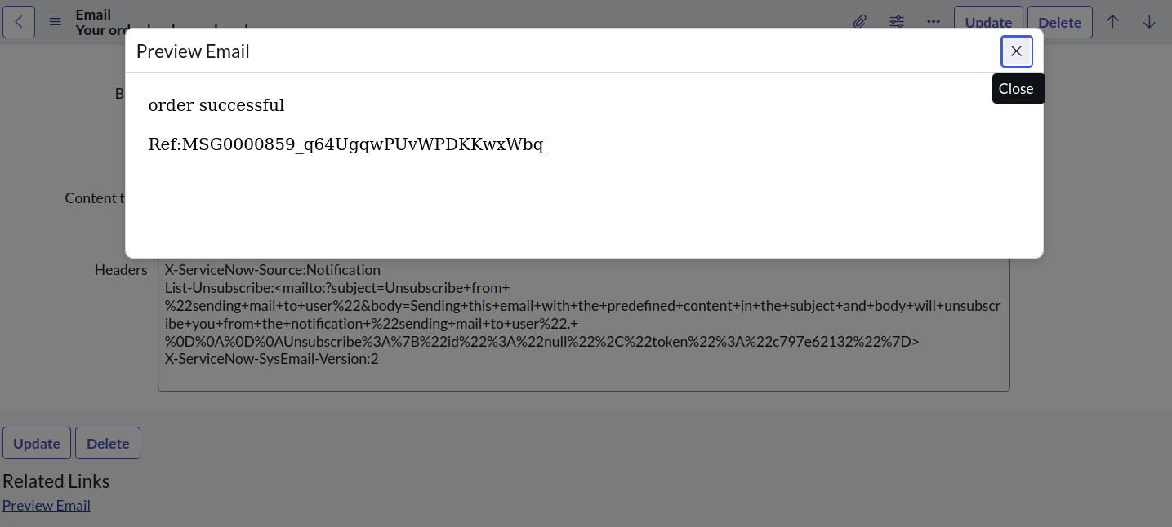

Order is placed successfully

### ****11. Conclusion****

This project transforms the manual process of ordering WiFi routers into an automated, user-friendly system. Key benefits include:

* **Efficiency Gains:** Reduced order processing time.
* **Improved Security:** Role-based access ensures data confidentiality.
* **Scalability:** The system can adapt to evolving business needs.

By addressing the challenges of manual workflows, the solution enhances both employee productivity and organizational efficiency.